**Technical Architecture:**

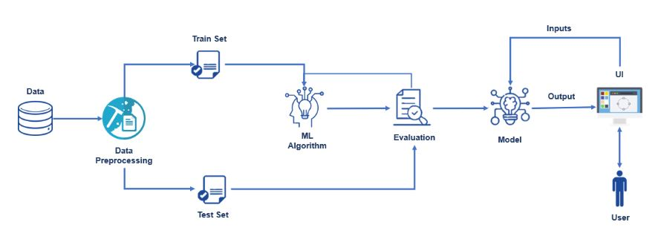

**Table-1: Technical Characteristics:**

|  |  |  |  |
| --- | --- | --- | --- |
| **S.No** | **Component** | **Description** | **Technology** |
|  | User Interface | How user interacts with application  Web UI | HTML, CSS |
|  | Application Logic-1 | Logic for a process in the application | Python |
|  | Machine Learning Model | Purpose of Machine Learning Model | ML Classifiers, etc. |

**Table-2: Application Characteristics:**

| **S.No** | **Characteristics** | **Description** | **Technology** |
| --- | --- | --- | --- |
|  | Open-Source Frameworks | It is a website which can be used on any platform to check whether a website is a phishing site or not. | HTML , CSS. |
|  | Performance | Only one model is used to detect whether or not a site is phishing, so it gives the result instantaneously after the details are entered and it is submitted. | ML Classification Models |